City of Malabon University

College of Computer Studies

Pampano St, Maya-Maya St, Longos, Malabon, Metro Manila

**Advanced Database System – Project Prototype**

**Submitted by:**

Forlaje, Mark Christian

Suñga, Carl Joseph

Buhayan, Ryann

Frayres, Raynier

Tamayo, Michael John

**BSIT 3G**

**Submitted to:**

Prof. Jay Concepcion

**Log in**

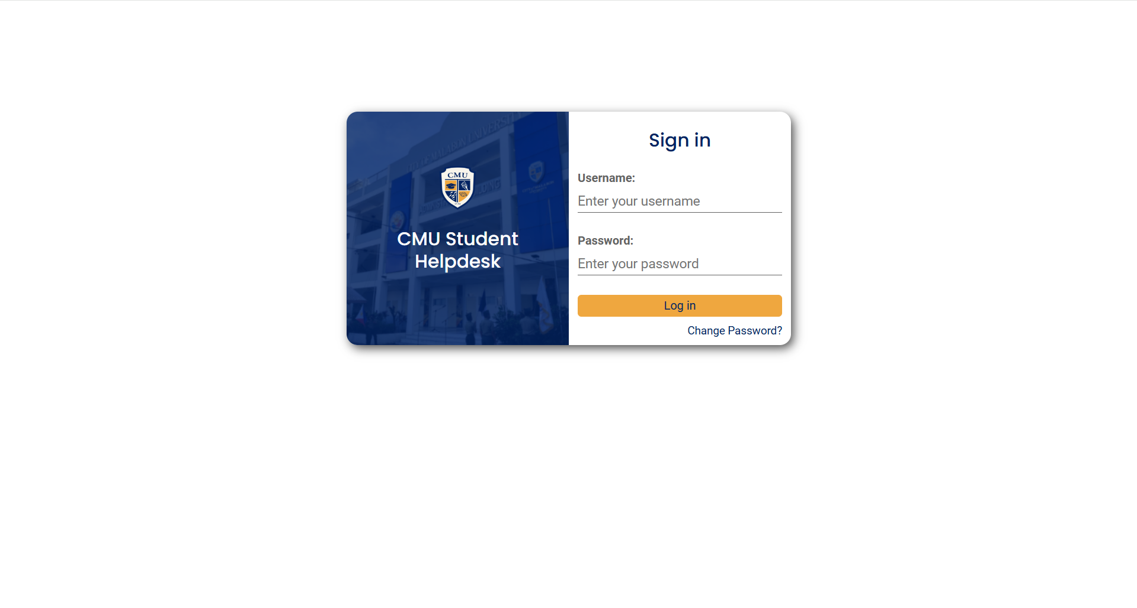

**Ticket List (Student)**

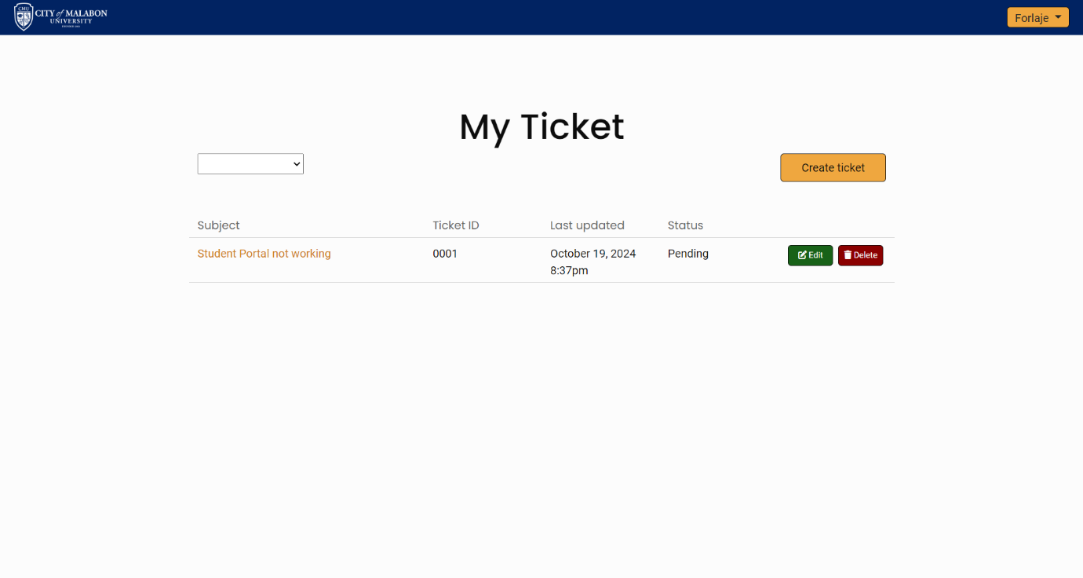

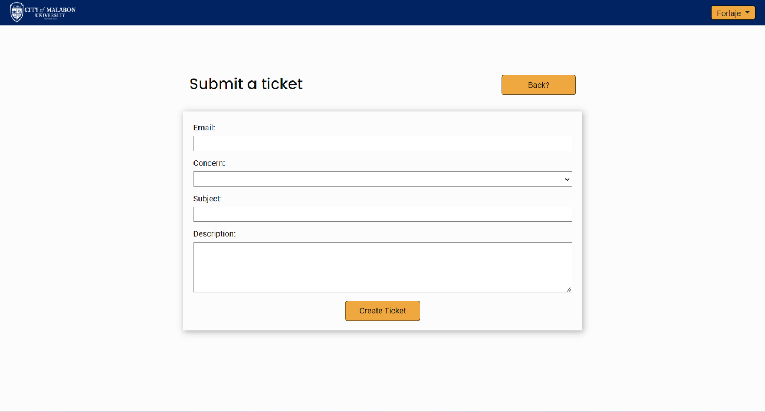**Create Ticket**

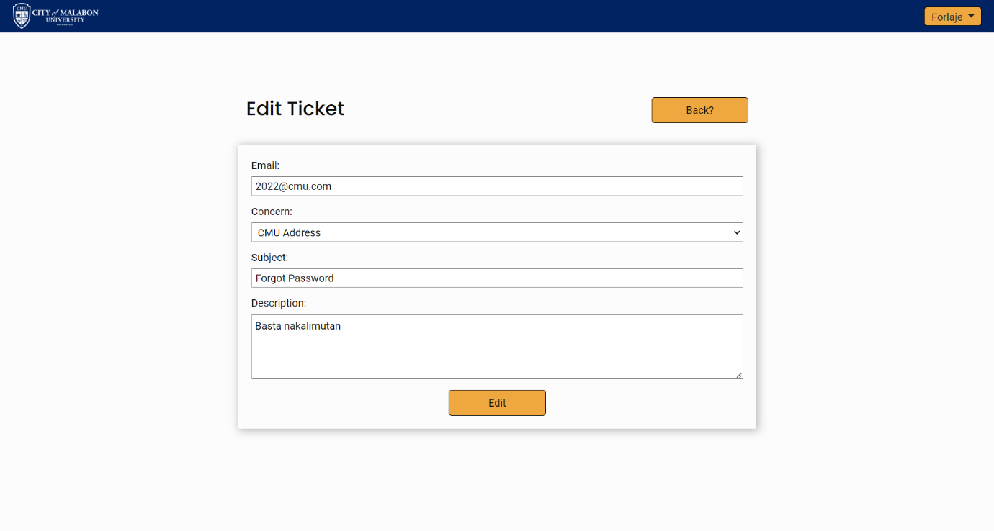**Edit Ticket**

**View Ticket**

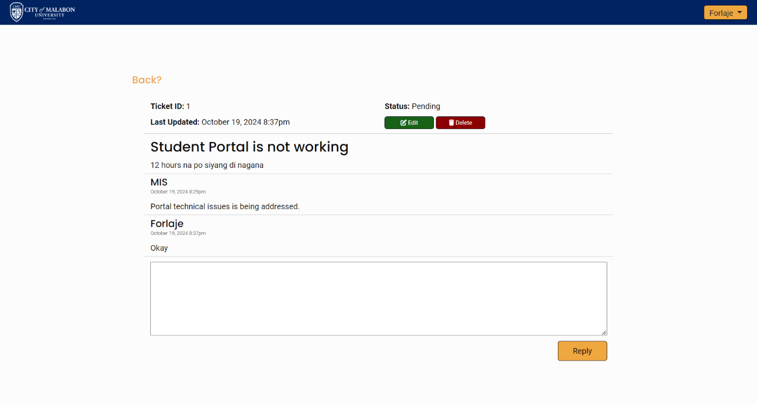

**Change Password**

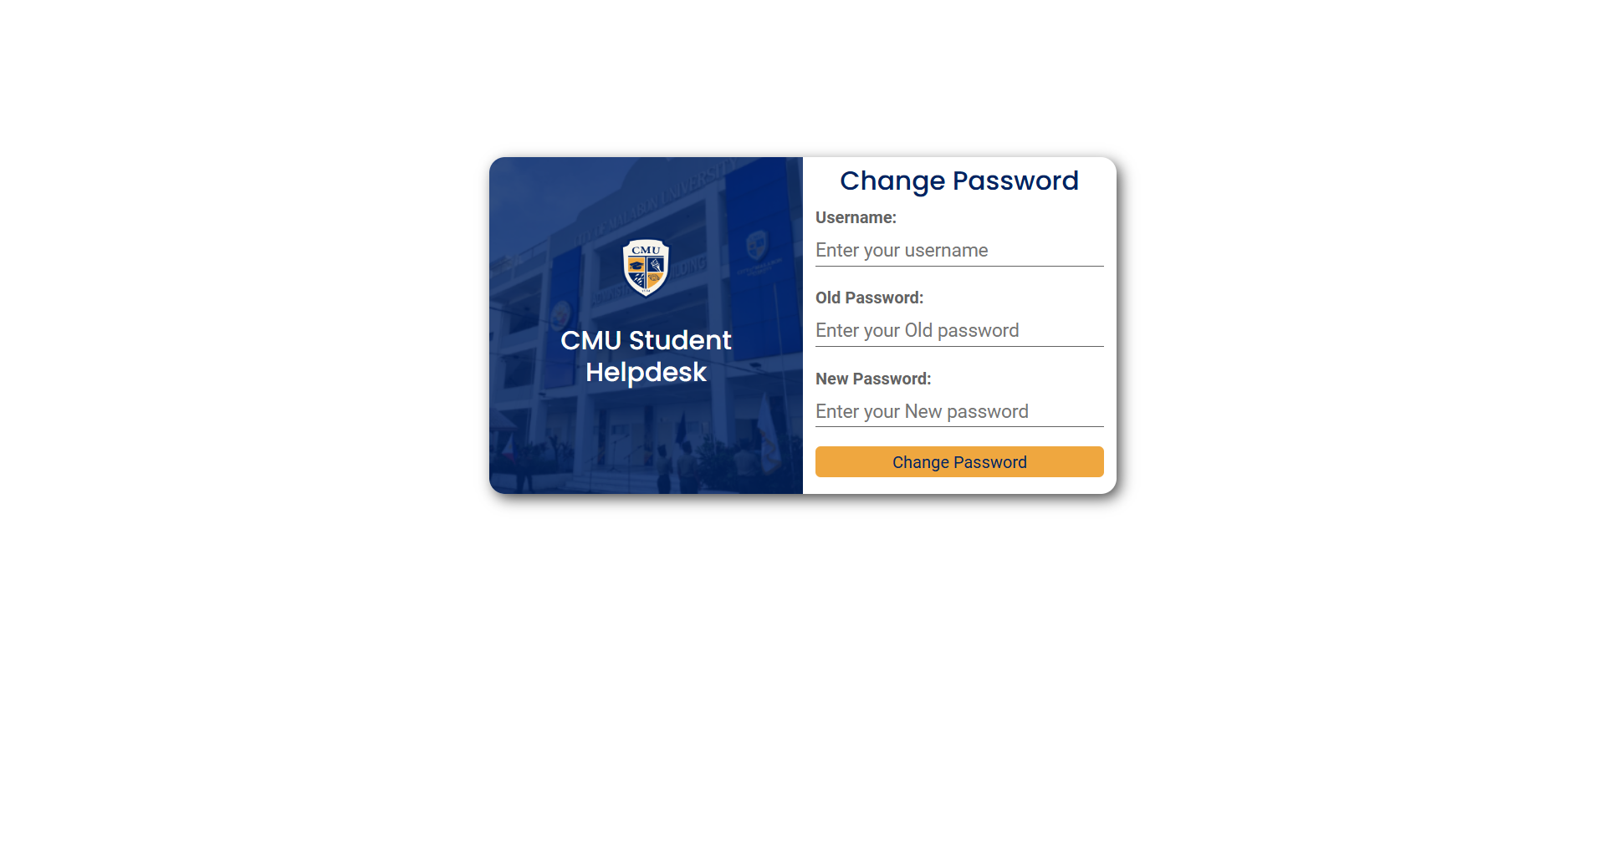

**Ticket List (Admin)**

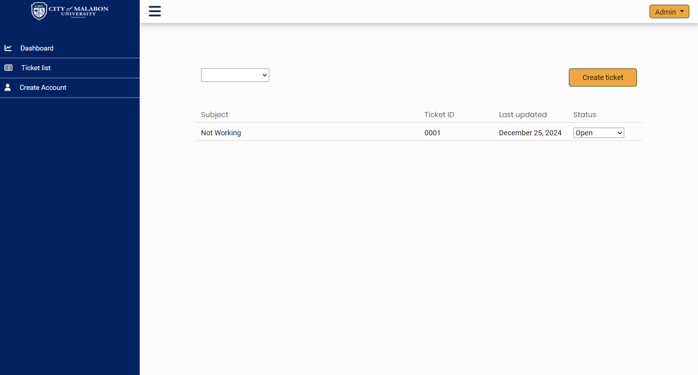

**Dash Board**

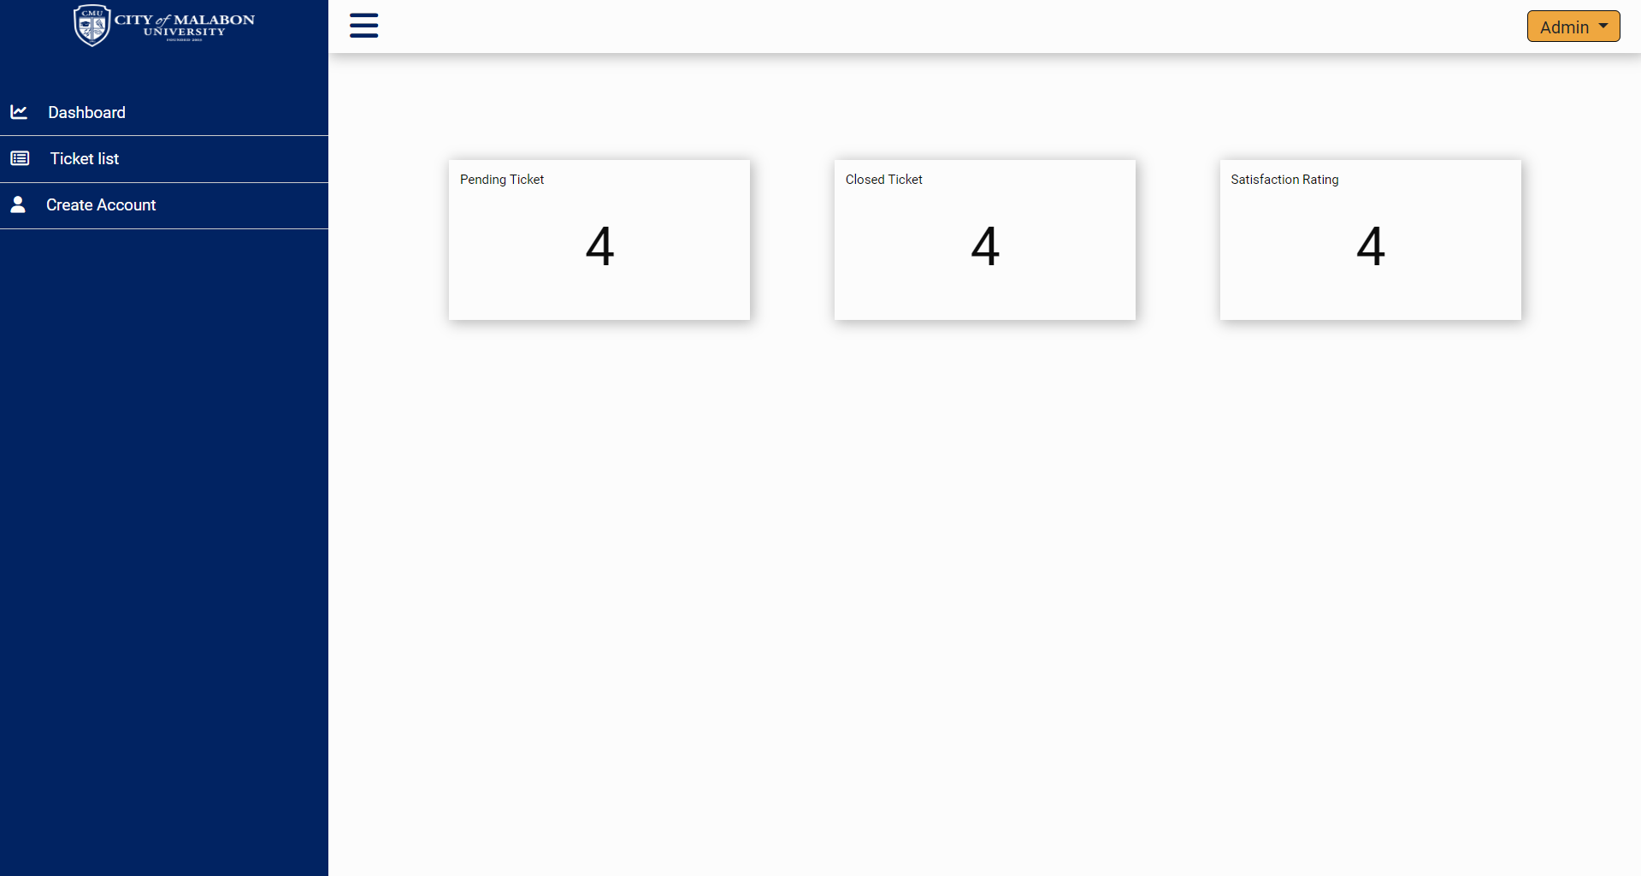

**View Ticket (Admin)**

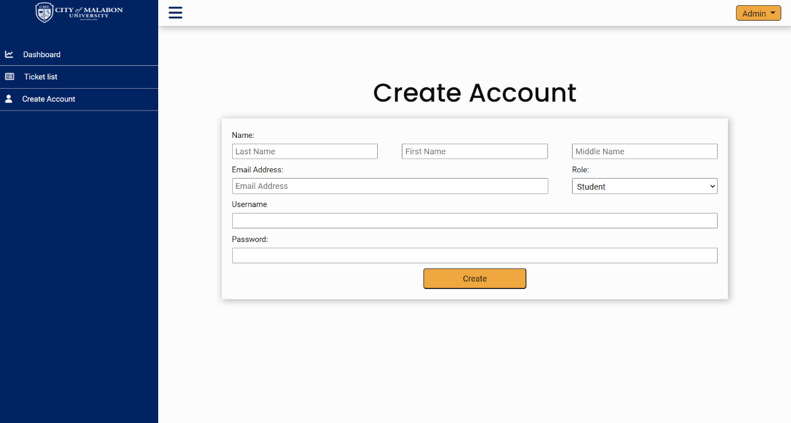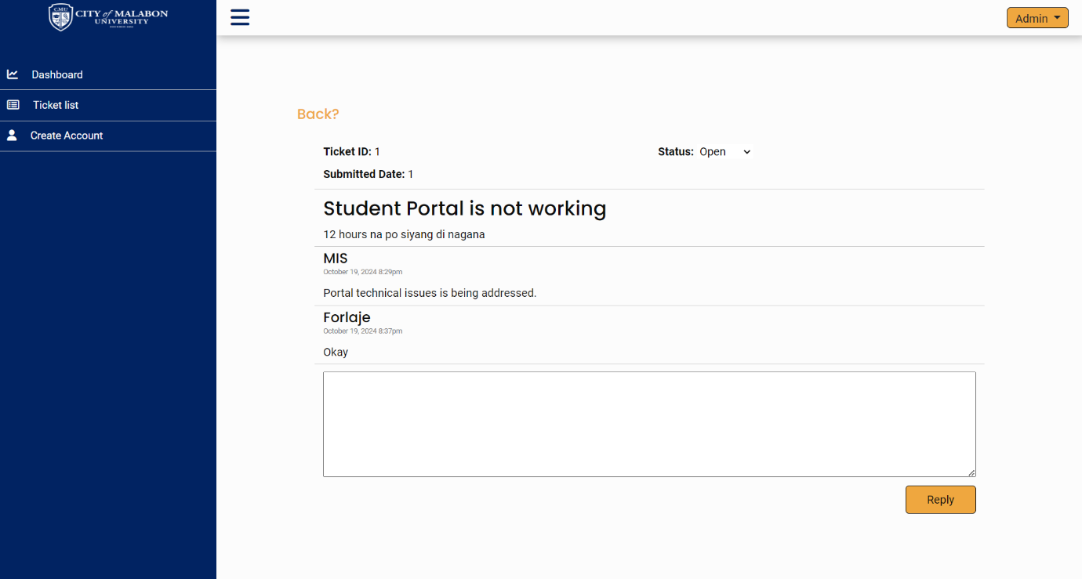**Create Account**